**RELATIONAL DATABASE DESIGN**

**LAB -1 ASSIGNMENT (GROUP PROJECT)**

**By:-Vidhya Venugopal**

1. URL LINK FOR ER DIAGRAM: -

https://lucid.app/lucidchart/b3223f0f-3de1-403e-857b-60fdca1f5e7b/edit?viewport_loc=-13%2C117%2C2833%2C1147%2CHWEp-vi-RSFO&invitationId=inv_83c95844-e2a2-44e4-b7d8-d24873f31159

1. ER DIAGRAM SNAPSHOT: -

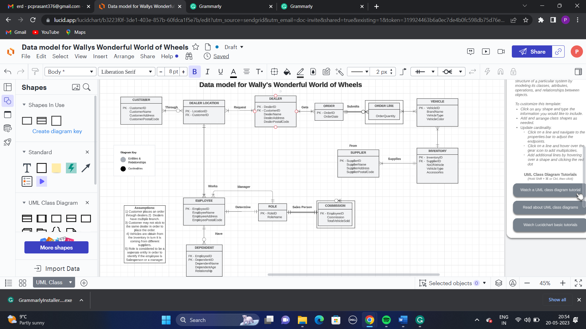

1. ER DIAGRAM PROCESS: -

With the specific instructions of Wally’s Wonderful World of Cars, we have developed an ER diagram for the company, The detailed process will be shared below points: -

There should be at least one or many customers placing the order through a dealer. The Customer Entity has many attributes such as CustomerName, CustomerAddress, CustomerPostalCode, and CustomerId as the primary key. Customers may place more than one order through dealers and the customer can choose various dealership locations (Cambridge, Kitchener, London).

The Dealerlocation Entity gets the input from the Customer Entity and then sends the request to the Dealer Entity. The Dealerlocation Entity may have many customers. The Dealerlocation Entity uses two attributes : LocationId, which is the primary key, and CustomerId, which acts as the foreign key.

Dealer Entity gets the customer information from the Dealerlocation Entity then the order is placed by the Dealer Entity. The Dealer Entity can make one or many orders, and the attributes of Dealer Entity includes DealerName , DealerAddress  
DealerPostalCode , DealerID as the identifier or primary key and CustomerID as the foreign key.

Once the order details are received from the Dealer Entity the Order Entity submits Order line. The Order Entity contains attributes such as OrderID(primary key) and OrderDate.

The Orderline Entity is a weak entity of Order Entity (Strong), The Orderline Entity is where the order is placed. Each order can have one or many Orderline instances. The attributes of Orderline Entity are OrderQuantity.

The Orderline Entity sends the order to the Vehicle Entity to match the product with the customer’s order. The Vehicle Entity is responsible to find out which vehicle is requested in the customer’s order. Each Orderline can have one or many Vehicles request. The attributes in Vehicle Entity are VehicleID which is the primary key, BrandName ,VehicleType , VehicleColor.

Once the order is matched with the vehicle needed by the customer, the next step is to check the inventory. The Inventory Entity has detail about the vehicles available for the customer. The Vehicle Entity then looks in the Inventory Entity for required vehicle and delivers it to the customer through the required dealer location. The Vehicle Enitity consists of attributes such as NoOfVehicle, VehicleType, Accessories and InventoryID(primary key),SupplierID(foreign key )

The Supplier Entity supplies vehicles to the inventory. The suppliers are from many categories such as auctions, bank foreclosures, other dealerships, and  
private sellers. The attributes of Supplier entity are   
SupplierName , SupplierAddress , SupplierPostalCode and SupplierID (primary key).

We have completed the process of the customer making an order and receiving it now let’s look into the company’s employees’ data.

The DealerLocation Entity has one or many employees, and each employee can work in only one dealer location. The Employee Entity has attributes EmployeeID(primary key)  
EmployeeName,EmployeeAddress,EmployeePostalCode

The employees are categorized based on the Role Entity into two categories which are manager and salesperson. If the employee is a manager, then the details of the employee whom he manages will be captured and if the employee’s role is a salesperson in the Role Entity, then the sales commission details will be captured in another Entity known as Commision Entity which depends on the strong Employee Entity. Therefore, Commision is a Weak Entity. The attributes of Role Entity are RoleID(primary key) and RoleName whereas the attributes of Commission Entity are EmployeeID(foreign key), Commission, TotalVehicleSold.

Finally, the details of the Employee’s dependent have to be captured. Employees may have as many dependents and dependents must have at least one employee. The Dependent Entity is connected to the Employee Entity. The attributes of the Dependent entity are EmployeeID(foreign key),DependentID(primary key),DependentName,DependentAgeRelationship.

THANK YOU !